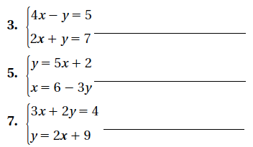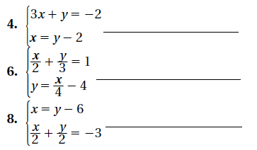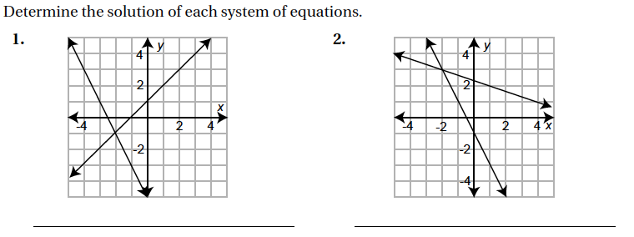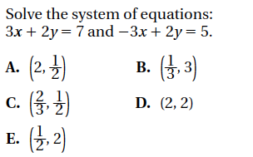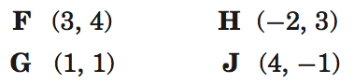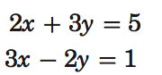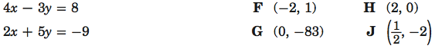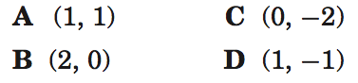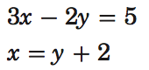

No work = no credit

Name _______________________________ Class ___________ Date __________________

6.4 Solving Systems of Equations by graphing

**12.**

**11.**

Solve each system of equations.