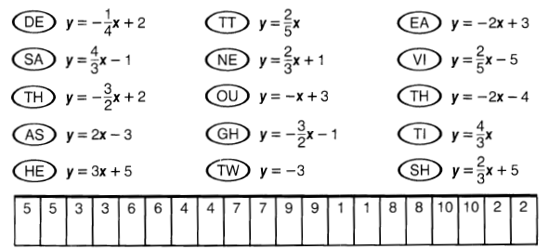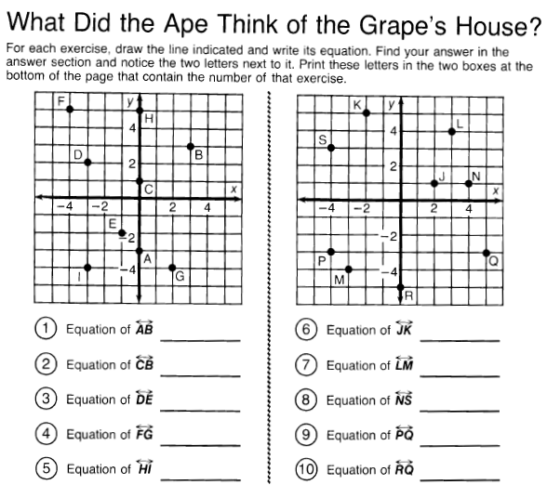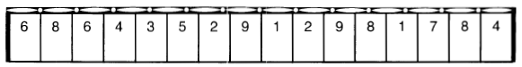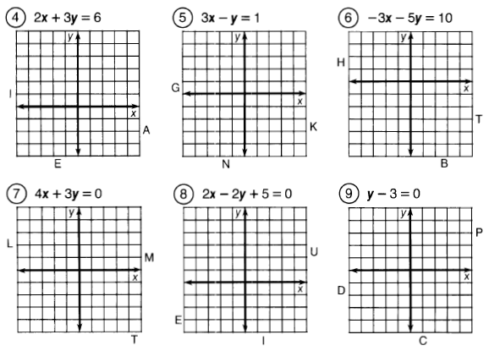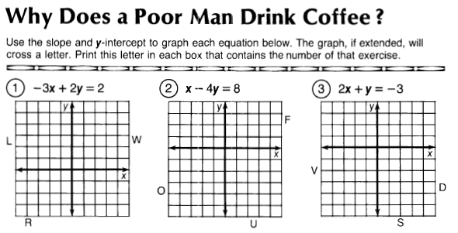

Name ___________________________ Class _________ Date_____________

Bridge Math Writing Equations of Lines Puzzles