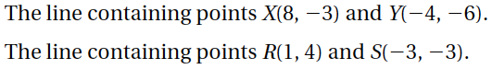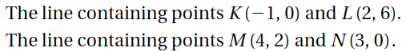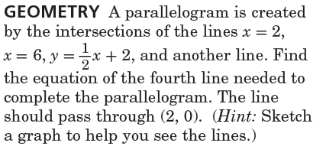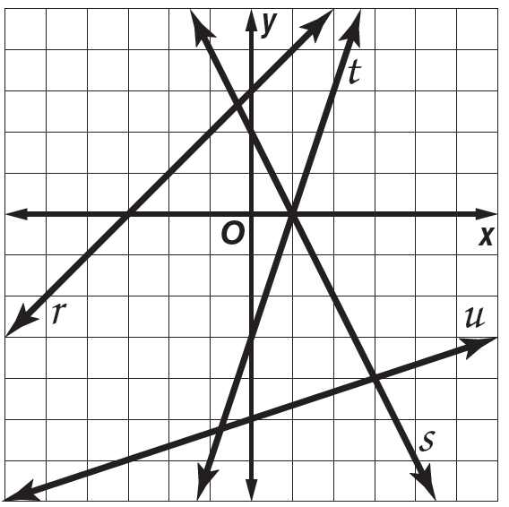

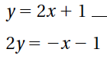

8.

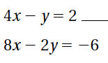

7.

6.

9.

|  |  |  |  |  |
| --- | --- | --- | --- | --- |
|  |  | Slope | Parallel | Perpendicular |
| 1. |  |  |  |  |
| 2. |  |  |  |  |
| 3. |  |  |  |  |
| 4. |  |  |  |  |
| 5. |  |  |  |  |

Name ________________________________ Class ___________ Date _________________

6.2 Part 3 Parallel &

Perpendicular Lines

No Work = No Credit

11.

**e. perpendicular to line s and through point (0, 0)**

**a. line *r***

**b. line *s***

**c. parallel to line *t* and through point (0,3).**

**d. perpendicular to line *u* and through point (-2, 4)**

10.