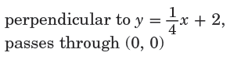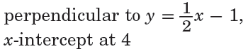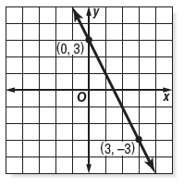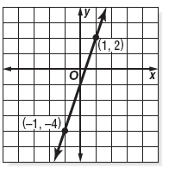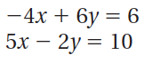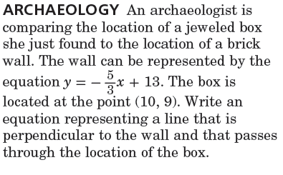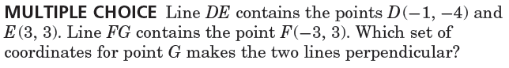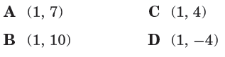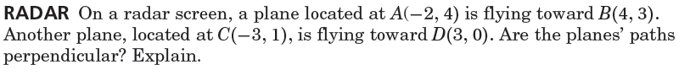

6.

5.

.

4.

3.

Through (-5, 1)

Through (2, -3)

2.

1.

Write the equation of the line perpendicular to the given function that goes through the given point.

Name ________________________________ Class ___________ Date _________________

6.2 Part 2 Perpendicular Lines

No Work = No Credit

B.

A.

9.

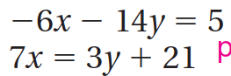

Determine if the following pairs of lines are perpendicular.

8.

10.

7.