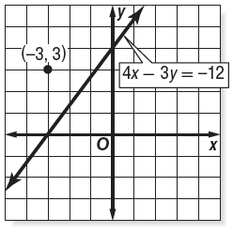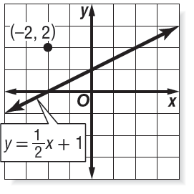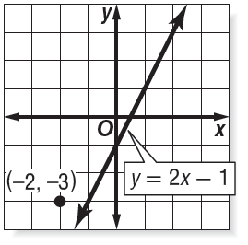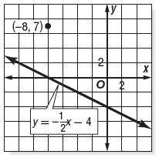

Name ________________________________ Class ___________ Date _________________

6.2 Part 1 Parallel Lines

No Work = No Credit

4.

3.

2.

1.

Write an equation for the line that passes through the given point and is parallel to the graph of each equation.

8.

7.

9.

10.

6.

5.