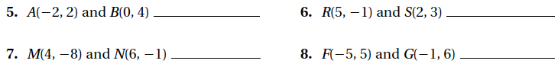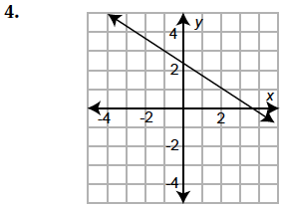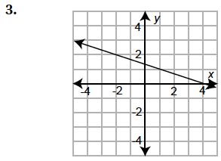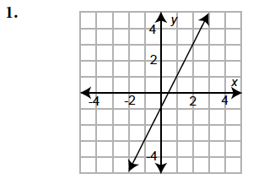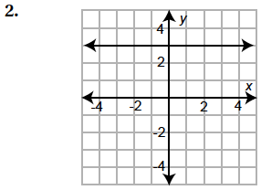 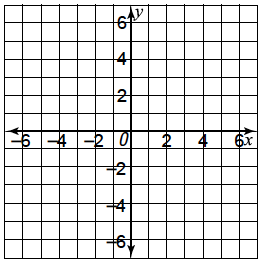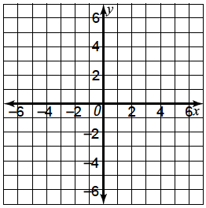

Find the slope of the line containing the given points.

M = ___________ B ___________

Equation: ____________________

M = ___________ B ___________

Equation: ____________________

M = ___________ B ___________

Equation: ____________________

M = ___________ B ___________

Equation: ____________________

Find the slope and y-intercept of each line. Then write the equation.

Name _______________________________ Class __________ Date ___________________

6.1 Slope and Slope-Intercept form of a Line

Find the slope and y-intercept for each function.

Write an equation of the line given the slope and y-intercept.

Graph each function.