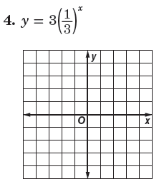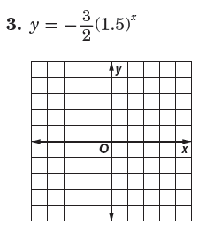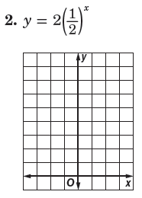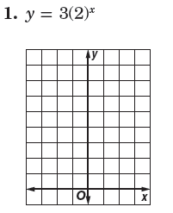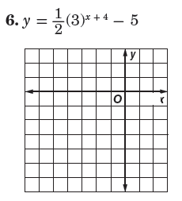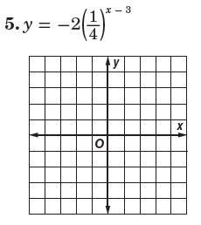

Graph each function. State the domain and range of each.

Name ________________________________ Class ____________ Date________________

8.1 Graphing Exponential Functions

7. The initial number of bacteria in a culture is 12, 000. The culture doubles each day.

a. Write an exponential function to model the population *y* of bacterial after *x* days.

b. How many bacterial are there after 5 days?

8. A college with a graduating class of 4000 students in the year 2008 predicts that its graduating class will grow 5% per year.

a. Write an exponential function to model the number of students *y* in the graduating class *t* years after 2008.

b. How many students can be predicted to graduate in the year 2018?