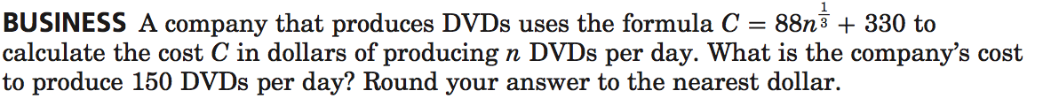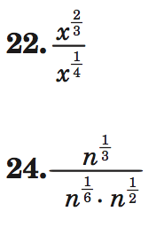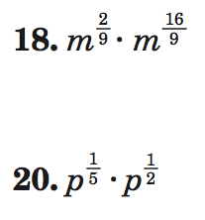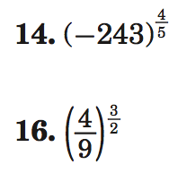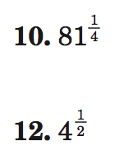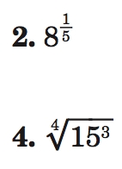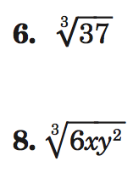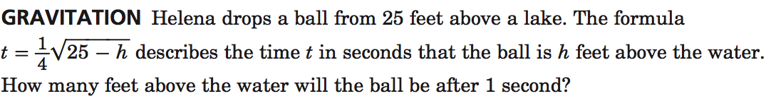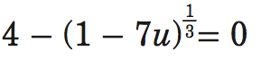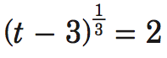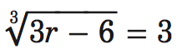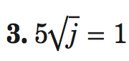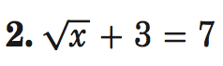

Simplify each expression.

Evaluate each expression.

Write each expression in radical form, or write each radical in exponential form.

Name ________________________________ Class _________ Date___________________

**7.6 Rational Exponents**

Solve each equation.

7.7 Solving Radical Equations