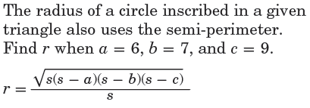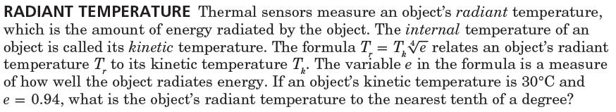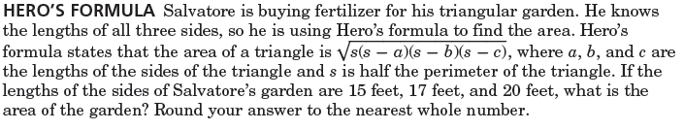

**Simplify each expression.**

Name ________________________________ Class ____________ Date_______________

7.4 Nth Roots

POWER

ROOT

2.

3.

1.

4.

8.

7.

6.

5.

12.

11.

10.

9.

16.

13.

14.

15.

19.

*Hint:*Get the value of **s** first, then use it to find r.

20.

18.

17.