# Algebra 2 Lessons 7-4 to 7-7 Test Review Name_________________________

**My Test is on ________________**

Simplify. (No decimal answers.)

1.  2.  3. 

4.  5.  6. 

7.  8.  9. 

10.  11. 

12.  13. 

Change from exponenetial form to radical form.

14.  15. 

Change from radical form to exponenetial form.

16.  17. 

Evaluate. No decimals – use a fraction if needed.

18.  19. 

Express in *simplest* radical form.

20.  21.  22. 

Simplify each expression. Write your answer with a rational exponent.

23.  24.  25.  26. 

27. 28.

29. 30.

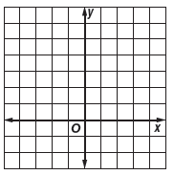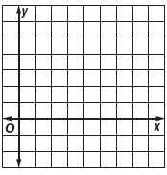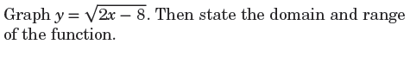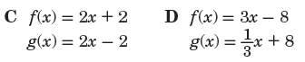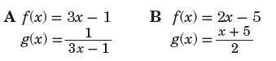31. F(x) = ${-2x}^{4}+{3x}^{2}+10x-7$ and G(x) = find F(x) – G(x).

**Domain:**

**______________**

**Range:**

**______________**