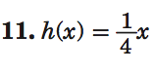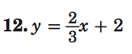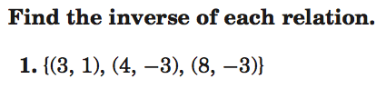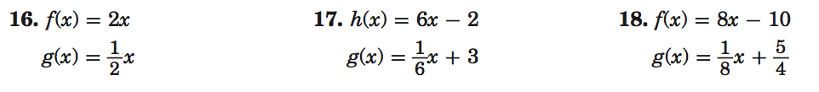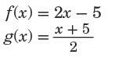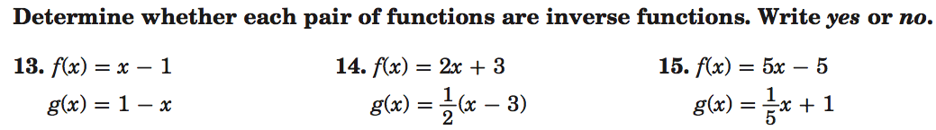

Name __________________________________ Class __________ Date ________________