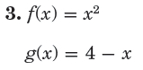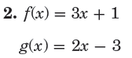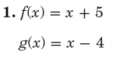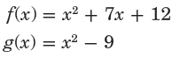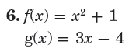



= _____________________________________

= _____________________________________

= _____________________________________

= _____________________________________

No Work = No Credit



= _____________________________________

= _____________________________________

= _____________________________________

= _____________________________________



= _____________________________________

= _____________________________________

= _____________________________________

= _____________________________________

Name _________________________________ Class ____________ Date _______________



= _____________________________________

= _____________________________________

= _____________________________________

= _____________________________________



= _____________________________________

= _____________________________________

= _____________________________________

= _____________________________________



= _____________________________________

= _____________________________________

= _____________________________________

= _____________________________________