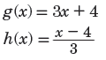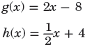

Name ________________________________ Class _____________ Date_______________

7.1 Operations on Functions and 7.2 Function Inverses Classwork

**No Work = No Credit**\*

C.

B.

A.

4. Find the inverse of each function.



= _____________________________________

= _____________________________________

= _____________________________________

= _____________________________________



= _____________________________________

= _____________________________________

= _____________________________________

= _____________________________________

2. f (b) =

g (b) = b + 3

1. f (x) =

g (x) = x - 5

Are they inverses? ________

D.

Are they inverses? ________

Are they inverses? ________

Are they inverses? ________

C.

B.

A.

5. Determine whether each pair functions are inverses. Write Yes or No.