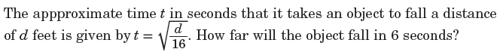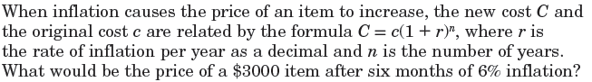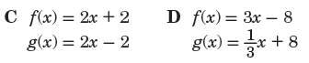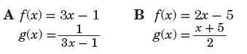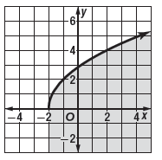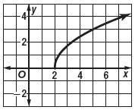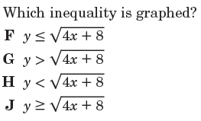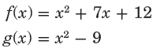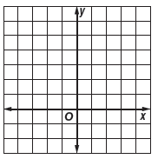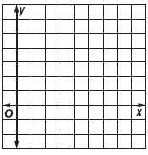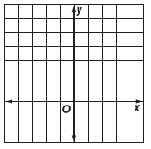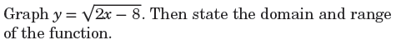

Chapter 7.1-7.3 Quest Review



= _____________________________________

= _____________________________________

= _____________________________________

= _____________________________________



= _____________________________________

= _____________________________________

= _____________________________________

= _____________________________________



**Domain:**

**______________**

**Range:**

**______________**

**Domain:**

**______________**

**Range:**

**______________**